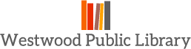
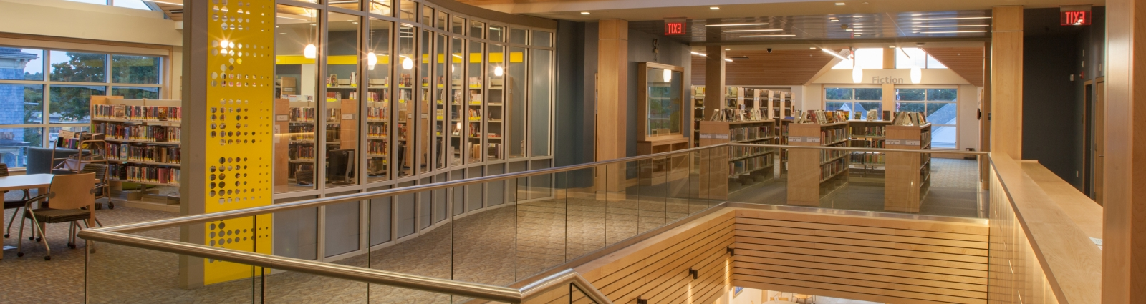
LONG RANGE PLAN

2017-2021
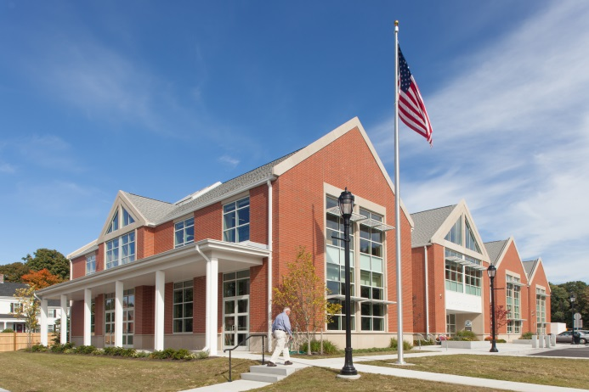
Westwood Public Library
660 High Street
Westwood, MA 02090
781-326-7562
www.westwoodlibrary.org

Approved by Board of Trustees: 12 September 2016
Amelia Rands, Chair
Wendy Thornton, Secretary
Jessica Cole
Paul Fitzgerald
Mary Masi-Phelps
Mary Beth Persons
Library Director, Tricia Perry

TABLE OF CONTENTS Page

Westwood Public Library – Vision Statement 3
Westwood Public Library – Mission Statement 3
Community Profile: Westwood Public Library -- A Brief Overview 4
Introduction and Methodology
Library Planning Process 6
Service Responses 7

Needs Assessment
Collections 9 Programs 9
Meeting Spaces 10
Accessibility 11
Technology and Resources 11
Islington Branch Library 15

Strategic Plan (Goals, Objectives, Actions and Measures)
Service Response 1 18
Service Response 2 20
Service Response 3 23
Service Response 4 24

Timeline 26(A)
(Excel insert)
Appendices
A: Invitation to Join Community Focus Group 27
B: List of Community Focus Group Participants 28
C: Annotated Survey Results
Compiled by Community Focus Group participant, Tina Bronkhorst 29
D: Survey Results (Google Docs) 37

Westwood Public Library – Vision Statement
The Westwood Public Library will provide excellent professional, educational and recreational resources for lifelong learning while fostering a culture of inclusion in a vibrant place that is free and welcoming to all.

The Library’s vision statement is consistent with the consensus of the community participants in the Library planning process, who embraced the following Community Vision for Westwood: that Westwood seeks to remain a vibrant, inclusive and cohesive community which values a high quality of town services while fostering continuing traditions of educational excellence, lifelong learning and intellectual curiosity, where a culture of diversity and civility are celebrated across all generations.

Westwood Public Library - Mission Statement

The Westwood Public Library provides high quality resources and diverse and creative opportunities for residents of all ages

- to satisfy their recreational interests and find information on popular cultural and social trends
- to use information on topics related to their work, school and personal lives
- to fulfill their need for personal growth and development
- to develop an understanding of their heritage and that of other cultures
- to join the community to discuss issues of common interest

With a broad collection of physical and electronic materials and programs, staff supports the pursuit of life-long learning. The Library serves the community as a meeting place for residents, municipal bodies and civic organizations.

COMMUNITY PROFILE: Westwood Public Library -- A Brief Overview
Westwood is a town of more than 14,000 people, located just 12 miles southwest of Boston. The town is convenient to Routes 95 and 128, and two commuter rail lines. In addition to an excellent location, Westwood is recognized for the quality of its schools. Town amenities also include a senior center, conservation areas, playgrounds, ball fields and an indoor pool facility. The town of Westwood is also home to Hale Reservation, a private, non-profit educational organization that manages 1,137 acres of woodlands, including four ponds and over twenty miles of trails. In March 2012, Boston Magazine selected Westwood as one of the best places to live in Massachusetts.

Westwood Public Library has a long history, originally established in 1895 as a branch of the Dedham Public Library. The site of the first library building, which was a gift to the town in 1895 from Howard Colburn, remains the approximate location of the new Westwood Public Library, which opened to the public in July 2013. The Colburn School Building, built in 1874 and voted eligible for inclusion in the National Register of Historic Places in 1999, was relocated twice: first to the rear of the new library construction site, and then to its present location, adjacent to the new library on High Street. History surrounds the Islington Branch Library as well, which is housed in Wentworth Hall, a building which dates to 1884.

The new library was made possible through the Massachusetts Public Library Construction Program (MPLCP), administered by the Massachusetts Board of Library Commissioners. Open and airy, the Westwood Public Library provides visitors with multiple options for accessing library materials and collections, and is a beautiful and engaging space of approximately 32,000 sq. ft. The library includes expanded collection space, two small (4 person) study rooms, and dedicated spaces for adults, children and young adults. There are two fireplaces, one located in the conference room, the second in the upstairs adult fiction stacks. The Conference Room, with space for approximately 25 and the larger Community Room, which holds 100, are very well used. These two community spaces are available for ‘after hours’ access. There is also a lobby level gallery area, which provides a lighted display area for monthly art shows featuring the work of local artists. This area also features a highly visible display area in which to showcase rotating book displays.

Population: The Westwood Public Library is a vibrant community gathering space for patrons and visitors of all ages, with varied and robust collections of library materials that engage the imagination, foster creativity, and invite discourse; and many of these patrons are adults! According to the 2010 census, more than two thirds of the population of Westwood is over the age of 25, with a median age of 41.5 years of age for the town’s residents. This includes approximately 5,602 citizens aged 40 – 64, and 2,657 over the age of 65.

- Education: Westwood’s educational system includes 5 elementary schools (Deerfield School, Downey School, Hanlon School, Martha Jones School and Sheehan School), as well as the Thurston Middle School (grades 6-8) and Westwood High School. Westwood has a long history of providing high quality education and opportunities to the more than 3200 students in PreK-12th grades. For the current year, High School enrollment at Westwood High School totals 1009:

- Class of 2017: 253
- Class of 2018: 248
- Class of 2019: 258
- Class of 2020: 250

The past several graduating classes have seen 95% electing to continue their educations at four-year colleges or universities, 1% at two-year colleges, and 1% in Career Education.
In addition, Xaverian Brothers High School is located in Westwood. Xaverian is a Catholic college preparatory school for boys in grades 7-12 with an enrollment of approximately 950, many of which are students whose families reside in Westwood. At present, four Westwood students are also enrolled at the Norfolk County Agricultural School in Walpole, and seven attend Blue Hills Regional Technical School which is located in Canton.
Public Library: The Westwood Public Library includes the Main Library (located at 660 High Street) as well as the Islington Branch Library (located at 280 Washington Street). Combined, these two library facilities are open 7 days a week for a total of 73 hours per week. Each location offers a variety of regularly scheduled events and programs for patrons of all ages. Meetings of town committees and organizations are regularly scheduled in the Main Library’s two meeting rooms, and many community groups and organizations also use this space.

Funding for the library is appropriated at the annual town meeting, and historically the town appropriates funding sufficient to meet the required standards for retaining certification. In addition, the Friends of the Westwood Public Library continue their efforts to supplement the library’s funding.

For FY17, the Library’s budget request of $1,217,089 represents a 4% increase over the FY16 budget. A significant portion of this increase is predicated on the estimated preventive maintenance costs for the automated materials handler – a cost that had been covered as part of an initial three-year contract that had not impacted the library’s operating budget. Going forward, this cost will be part of the library’s operating budget.

Library staff consists of 9 full time and 17 part time employees, with a FTE of 16.87. This past year the Library was able to re-structure two positions in the circulation department, resulting in an additional benefitted position for the Circulation Department. The Library Board of Trustees is made up of six elected members who serve three-year staggered terms. The Library Director has reporting responsibilities to the Board of Trustees as well as the Town Administrator, with the Town Administrator designated as the official appointing authority.

Adult Programming: In the fall of 2015, a new Adult Services Librarian was hired to replace a retiring staff member who had worked at the Library for 25 years. In an effort to gauge community needs and interests, the Library conducted a brief patron survey in September 2015, focusing specifically on adult programming and services. 90% of the fifty-two adults who responded indicated that their primary focus of going to the library was to “check out books.”

Additionally, when asked what types of adult programs they would most likely attend in the future, the following two top responses were observed:
- Author Talks (67%)
- Book Groups (39%).

Children’s Programming: The Children’s Department offers a wealth of programming throughout the year. This summer, the Reading Program and storytimes attracted approximately 1,000 young patrons. School-year storytimes for different ages are offered at both the Main and Branch libraries; other programs include music, drama, and yoga. Each year the entire sixth grade visits the library for a structured program of books talks and review of library resources. The Department maintains an active social media presence and collaborates regularly with town agencies and community groups, as well as with the schools.
INTRODUCTION AND METHODOLOGY
Library Planning Process
Planning for the development of a new strategic plan for the Westwood Public Library began in the fall of 2015, as we began to shift our focus from building and construction of the new Main Library to revitalization of all of our library services.
When the Trustees and Director first began discussion of the need for a new strategic plan this past fall, the Westwood Public Library was in the midst of planning for an eleven week closure for the ceiling tile replacement project. We re-opened the building in January 2016, and shortly thereafter began sharing information with staff and the community about the library’s strategic planning process.
Consultant: Nancy Rea: Nancy Rea, a former Deputy Director of the Massachusetts Board of Library Commissioners (MBLC) was hired by the Board of Trustees as a consultant. Nancy has over thirty years of experience and commitment to library service and is a well-known and highly regarded consultant for library planning. Nancy facilitated the meetings of the Community Focus Group and the Staff Focus Group. She also provided insight, encouragement and guidance throughout this planning process.

Community Survey: An online survey was developed and was made available in March and April. (Survey closed on 4/15/16). The survey was published using GoogleDocs, and while most respondents did use the online version, print copies were also made available at the Islington Branch Library, Town Hall and the Council on Aging. Respondents who used the paper version had their responses entered manually into the online survey. The survey generated 326 responses. APPENDIX C: Survey Results

Community Focus Group: .
To launch the strategic planning effort, invitations were extended to approximately 40 individuals in the Westwood community in February 2016 asking if they would consider participating in a Community Focus Group which would be held in April.

The individuals participating in the Community Focus Group formed one of two basic working groups for the formulation of this new strategic plan for the Westwood Public Library (with the Staff Focus Group being the other working group). The group made thoughtful assessments and provided great suggestions and feedback to the Trustees and Director in terms of the goals and general objectives and in defining the community vision. The participants in the Community Focus Group were an invaluable resource in the formulation of this strategic plan.

Focus Group participants represented a broad spectrum -- reflective of the greater community of Westwood. This group of community representatives included many individuals who are active in local organizations, or who hold positions on town boards. Some were members of town departments, including Fire, Police, school staff and administrators, Youth and Family Services, Council on Aging and Recreation. Others were selected because the work that they do professionally or as a member of the community contributes to a more thorough understanding of all of the components that make up our Westwood community

Individuals were asked to commit to one 3 hour meeting, which would be held in the evening at the library. The Community Focus group reviewed an information packet provided by the Library Director in advance of the meeting. During the meeting, the Library Director shared an overview of the Westwood community and a brief history of the Westwood Public Library.

The meeting was then turned over to our facilitator and consultant, Ms. Nancy Rea. Ms. Rea guided the group through a number of exercises, first to define a shared vision for Westwood’s future, then to identify library and community strengths, opportunities, aspirations and results. The group also reviewed the 18 Public Library Association (“PLA”) service responses (Sandra Nelson, Strategic Planning for Results. American Library Association, 2008.) Participants were asked to select the service responses that they felt that the Westwood Public library might fulfill in the community.

(Letter of invitation and list of participants can be found in Appendix A and Appendix B.)

Staff Focus Group: A second focus group for staff and Trustees was held on Thursday, April 28th. This meeting was also facilitated by Ms. Nancy Rea. The agenda was similar in scope to that of the Community Focus Group, with the addition of discussion of Library Mission and Vision Statements. This meeting was open to all library staff (full time, part-time and “on-call”).

Development of Strategic Plan: Over the next several months, library staff and Trustees reviewed the input provided by the Community Focus Group and the Staff Focus Group. After significant deliberation and discussion, the library selected four primary library service responses (see below) that reflect local priorities and best utilize the strengths and opportunities and aspirations of the Westwood Public Library.

The final Strategic Plan helps us more effectively plan for the future. The plan will inform the decisions that are made for all potential resources, collections, services and programs to determine how they align with the four specific service goals – and also respond to the specific goals and objectives and output measures related to these responses for the next five years.

Service Responses

SERVICE RESPONSE 1: Stimulate Curiosity and Imagination-- Reading, Viewing and Listening for Pleasure

Goal: Residents will have easy access to materials that will enhance their leisure time and will have the help they need to make choices from among the options.

SERVICE RESPONSE 2: Lifelong Learning--Make Informed Decisions and satisfy curiosity; Express Creativity, Create and Share Content

Goal: Westwood residents will have the resources they need (including print, video, audio, or visual content in a real-world or online environment) to explore topics of personal interest. They will be encouraged to read, explore, and discover new ideas at all stages of life and continue to learn throughout their lives.

SERVICE RESPONSE 3: Create Young Readers (Birth through age 18)

Goal: Foster a culture of literacy that engages and captures the imagination of young readers (birth – age 18) and keeps them engaged with reading and literacy throughout their youth.

SERVICE RESPONSE 4: Visit a Comfortable Place

Goal: The Westwood Public Library will be the “hub” of the community. Residents of all ages will have safe and welcoming physical places to meet and interact with others or to sit quietly and read, work and study, and will have open and accessible virtual spaces that support collaboration and networking.

Needs Assessment
Collections
The collections of the Westwood Public Library are extensive and well utilized by the community.
In FY2015, the Library had 156,574 volumes in the collection. In recent years, the Westwood Public Library has also increased the e-resources available to patrons, including Overdrive, Overdrive Advantage copies and Hoopla digital downloads.

Looking at circulation statistics provided by the Massachusetts Board of Library Commissioners (MBLC), in 2015, the last year for which comparative data is currently available, Westwood’s total circulation per capita was 20.68. This puts Westwood well above the median per capita circulation of 9.32 for Massachusetts public libraries, and also well above the state-wide average of 11.52. Overall, in 2015, Westwood placed 45th of 370 Massachusetts libraries in terms of per-capita circulation, based on the population served by the library and including items lent to other libraries.

Westwood has robust collections; including a well-used TRAVEL section, and a strong FINE ARTS collection. Non-print resources continue to gain in popularity. In 2016, non-print resources (audio-visual; e-resources) accounted for 39% of the library’s total collection. (2016: Total Holdings: 174,596; Print Holdings: 107,442; Non-Print Holdings: 67,514). In 2010, non-print holdings accounted for only 12% of the Westwood Public Library’s total collections of 105,131.

Programs
In August 2015, Molly Riportella was hired as the new Head of Adult Services. Under Molly’s guidance and direction, adult program attendance has increased 301% over this same time period as last year. This is a direct result of increases in both the number and variety of adult programming. Some of the offerings have included monthly mystery and fiction book discussions, the Great Decisions Program, featuring monthly discussions of politics and current affairs, and programs involving health and wellness, art, music, history, poetry and elephants! (In April, author Vicki Croke presented a book talk on Elephant Company).

Westwood has a long tradition of excellent children’s programming, and our children’s librarians work tirelessly to continue to provide excellent children’s services and a strong literacy connection for children and families in the community. Collaboration and outreach opportunities are continually expanding. Every year, towards the end of the school year, our children’s staff begin their outreach to introduce the summer reading program. This involves individual classroom visits by our children’s library staff to approximately 65 classrooms during the month of June. Book talks, book shares and animated conversations (sometimes accompanied by felt boards or other activities) are part of each visit.

One of the most popular summer reading incentives this past summer rewarded readers with more than 50 hours of reading to qualify for the “Summer Reading Champion Lives Here” Yard Sign. There was so much interest and enthusiasm from children that our children’s librarians had to re-order the signs twice over the course of the summer. This summer 955 children registered for the children’s summer reading program and at the conclusion of the summer reading, Westwood has over 150 young readers proudly displaying their “Summer Reading Champion Lives Here!” lawn signs across the entire town!

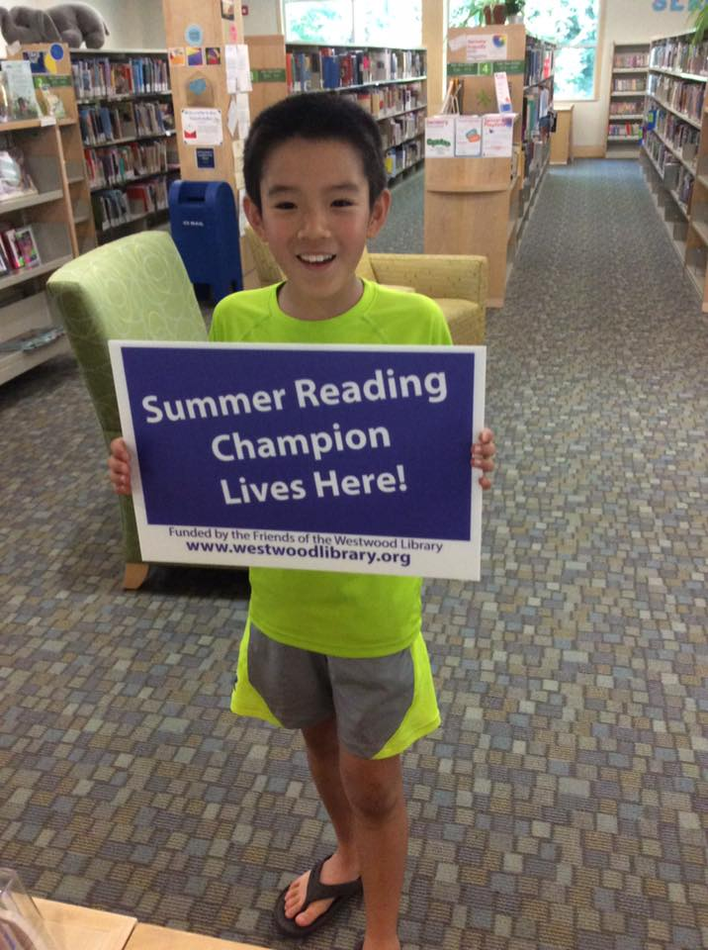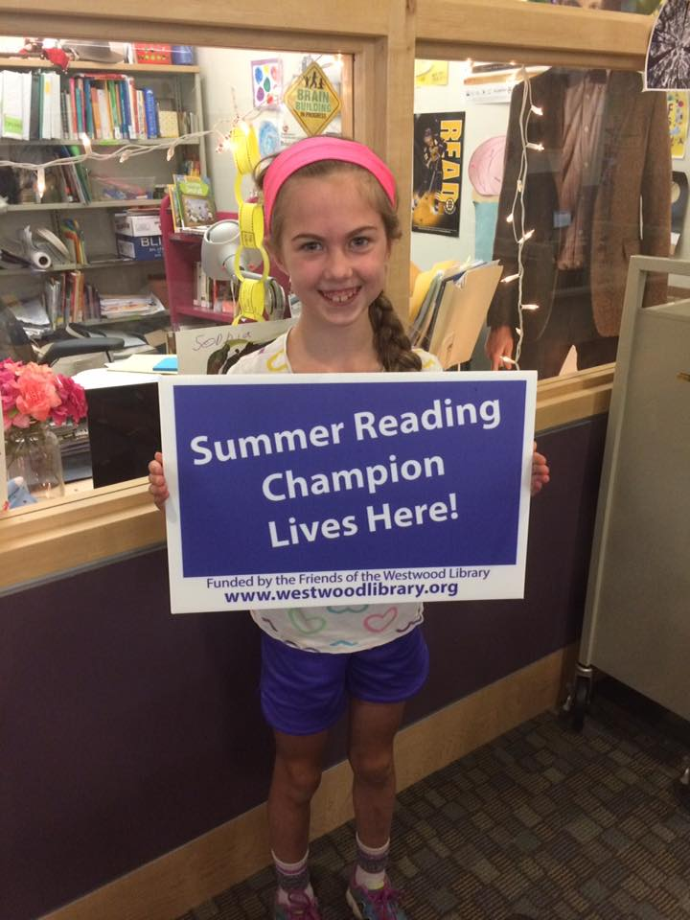

Teen outreach includes an annual visit to the Library by the entire sixth grade in the fall. This is a full half-day exploration of library collections and programs, with children’s and teen librarians sharing information about what is available for students at their public library, including librarians with professional expertise, e-resources, databases and highlights of the teen and ‘tween collections.

Meeting Spaces
One of the most anticipated and well-utilized areas of the new library are the large public meeting spaces located on the first floor and the two small individual (4-person) study rooms which are located on the second floor.
The large meeting room spaces are intended to provide space for library activities and for use by local, non-profit groups and organizations sponsoring civic, cultural and educational events. While Library-sponsored activities have priority in consideration of the room use, when they are not in use by the library these spaces are made available to other groups and organizations. And there is rarely a day when these rooms are not used for multiple events! The library’s community spaces include a Community Room (capacity 85) and a Conference Room -- featuring a gas fireplace! (capacity 25). Both rooms have projection capabilities. Rolling tables and stackable chairs allow these spaces to be readily re-configured based on the requirements of the group.
These spaces are also able to be used “after hours” by groups, as they are accessible through a separate corridor and an interior grate isolates these areas from the library when events or programs are scheduled during non-library hours.
A large gallery space separates these “after hour” meeting rooms. The gallery houses monthly exhibits of art representing a wide variety of artists from the Westwood community. This past year, gallery shows have included exhibits of Mass Scribes Calligraphy, portraits and seascapes by Bud Burnham, horses and landscapes by Rob Franco, a collaborative Westwood School and Westwood Land Trust exhibit, an exhibition of the local art guild, a photography exhibit, and the art of a very gifted and talented middle school student, Nayderson Fallon. The gallery area also has several tables and chairs which lend themselves to impromptu gatherings of patrons of all ages.
In addition to the two community meeting spaces, there is also a large storytime area adjacent to the Children’s Department. This area is not accessible after hours and is not typically programmed for outside use other than for organized Westwood youth programs, such as the Early Childhood Council or similar groups with appropriate adult supervision. This room has a capacity of 35.
Accessibility
The Main Library is easily accessible for patrons of all abilities. The building is a two-story design, with an elevator located in the lobby. ADA doors allow for easy egress into and out of the building. Natural light is plentiful throughout the building during the daytime, allowing for a sense of integration between the building and the natural environment.

There are seven restrooms in the Main Library and all are ADA compliant. The multi-stalled Mens’ and Ladies’ Rooms on the first floor are able to accessed when the building is used after hours. In addition, there are two individual restrooms located in the Children’s Department, and two individual public restrooms as well as an individual staff restroom on the second floor.

The Westwood Public Library is committed to improving access. Librarians have participated in meetings recently to review low vision resources and technologies, and part of our strategic plan will address steps that we will be taking to provide better access to all patrons. We are also working closely with the Westwood Council on Aging to provide “Doorstep Delivery” of library materials to home-bound individuals.

Technology and Resources
Minuteman Library Network and Resource Sharing: The Westwood Public Library has been a member of the Minuteman Library Network since 1984. The Minuteman Library Network (MLN) is a consortium of 43 libraries with 62 locations and a Central Site staff that work collectively to provide excellent service to its library users. The members include 36 public and 7 college libraries in the Metrowest region of Massachusetts. The vision of the Minuteman Library Network is to foster a strong community of libraries providing people with optimal access to resources and information. This vision is realized through the Network’s mission to strengthen member libraries through innovative and economical technologies, efficient resource sharing, collaboration and shared expertise.
As a member of the Minuteman Library Network, Westwood patrons have access to the complete holdings (currently numbering over 6 million items) via a shared library catalog for our member libraries. This shared web-based catalog offers an easy interface for finding current information on the location of these items, including books, periodicals, and audiovisual materials.
In FY16 over 1.88 million items were shared among MLN libraries. This figure includes the 39,052 items that were provided to other libraries by Westwood in FY16, as well as 30,693 items received. Our patrons may visit any MLN library in person to borrow materials, seek information, do research, or just browse. MLN members use delivery services provided by the Massachusetts Library System (MLS) and materials are transferred between libraries on a daily basis.
Westwood Library Technology
A new library website was rolled out to the public in July 2015: www.westwoodlibrary.org. The website provides access to the Minuteman Library Network shared catalog, as well as numerous databases and e-resources. In addition, information about library hours and directions, programs and resources are easily accessed via this website. Blog posts and Facebook pages are also extremely popular with our patrons and our library staff ensure that the Library’s social media presence is kept current and refreshed on a regular basis.

The Library’s technology resources are also supported by the Town of Westwood Information Systems Department. The Town’s I/T staff work collaboratively with the Library’s Technology Librarian and library staff to provide resources and financial assistance to the library’s technology requirements.
Free Wi-Fi is available to all patrons at the Main Library and at the Islington Branch Library. The library also offers wireless printing, scanning and fax stations, b/w and color printing and photocopying options. Technology classes and technology “drop in” sessions are regularly offered by the Adult Services and Reference Staff.

Library patrons have access to 22 public computers. There are two dedicated desktop “catalog only” stations on the second floor of the Main Library as well as 1 “catalog only” station in the Children’s Room. Three wall mounted catalogs are located in the stacks for quick access. There are also 26 computers dedicated for library staff use.

Westwood patrons also have access to databases sponsored by the Massachusetts Board of Library Commissioners, the Minuteman Library Network, and several databases purchased by Westwood for Westwood patron use. These include online access to the following resources:

Antiques
- Price It! Antiques and Collectibles

Biography
- Biography In Context

Books & Authors
- Artemis Literary Sources
- Books & Authors
- eSequels
- Literature Resource Center
- NoveList

Business and investing
- Business Insights: Essentials
- Business Collection
- Morningstar Investment Research Center: Home access is limited to Westwood residents

Children
- Britannica Learning Zone (early childhood)
- Britannica Online Public Library Edition Kids
- Britannica Online School Edition (Elementary, Middle and High School levels)
- Kids InfoBits
- Research In Context
- True Flix : Home access limited to Westwood residents only
- TumbleBook Library : Home access limited to Westwood residents

Community Information
- Town of Westwood
- Westwood Schools
Computers/Technology
- Learning Express Library – Popular Software Tutorials

Consumer information
- Boston Consumers’ Checkbook : In Library Use Only – no home access
- Central Register & Goods and Services Bulletin : In Library Use Only – ask the reference librarian to log you in
- ConsumerReports.org : Home access is limited to Westwood residents.

Country Studies
- A to Z the USA : Home access limited to Westwood residents
- A to Z World Travel : Home access limited to Westwood residents
- Britannica World Data Analyst

E-books and E-audiobooks
- Minuteman Digital Catalog Overdrive
- Hoopla
- Zinio

Economics
- Boston Consumers’ Checkbook : In Library Use Only – no home access
- The Value of a Dollar 1860-2014, 5th Edition: Home access limited to Westwood residents

Education and Careers
- Criminal Justice Collection
- Cypress Resume : Home access limited to Westwood residents
- Educator’s Reference Complete
- Testing and Education Reference Center with Career Module : Home access limited to Westwood residents
- Vocations and Careers Collection

Encyclopedias
- Britannica Online School Edition (Elementary, Middle and High School levels)
- Britannica Online Public Library Edition
- Britannica Online Public Library Edition Kids
- Britannica Spanish Reference Center (Enciclopeida Moderna & Escolar Online)
- World Book Online : Home access limited to Westwood residents only

Environmental Studies
- Environmental Studies and Policy Collection

General reference
- Academic OneFile
- CQ Researcher : Home access limited to Westwood residents only
- Expanded Academic ASAP
- Gale Virtual Reference Library All titles | Adult and Young Adult titles | Teen titles
- General Onefile
- Global Issues in Context
- Infotrac Junior Edition
- Infotrac Student Edition
- Opposing Viewpoints in Context
- Pop Culture Universe : Home access limited to Westwood residents only
- PowerSearch Gale Databases
- Research In Context
- World Book Online

Geography
- A to Z Maps Online : Home access limited to Westwood residents only
- State Geography : Home access limited to Westwood residents only
- World Geography : Home access limited to Westwood residents only

Health and Medicine
- Health and Wellness Resource Center
- Health Reference Center Academic
- Nursing and Allied Health Collection Resource Center
- Nursing Resource Center
- Physical Therapy and Sports Medicine Collection

History
- American Government : Home access limited to Westwood residents only
- Historical Society of Westwood and the Fisher School
- Westwood High School Yearbooks (1946 - 2012)
- Britannica Annals of American History
- Massachusetts History Online
- This Is Who We Were : Home access limited to Westwood residents only
- U.S. History in Context
- Working Americans : Home access limited to Westwood residents only
- World History: the modern era : Home access limited to Westwood residents only
- World History in Context

Languages
- Mango Languages : Home access limited to Westwood residents only

Law
- Legal Forms: Massachusetts : Home access is limited to Westwood residents only
- Criminal Justice Collection

Lifestyle
- Culinary Arts Collection
- Gardening, Landscape and Horticulture Collection
- Global Road Warrior : Home access limited to Westwood residents only
- Hospitality, Tourism and Leisure Collection

Library Catalogs
- Minuteman Library Network Catalog
- Commonwealth Catalog
- Massachusetts Library Networks
- WorldCat.org

Magazine and Journal Articles
- Electronic Journals, Magazines and Newspapers Finder
- Academic OneFile
- General OneFile
- Gale PowerSearch

Newspapers
- Boston Globe (1980 - to date)
- Historical Boston Globe (1872-1979) : Home access limited to Westwood residents only
- New York Times (1985 - to date)

Science
- Science in Context

Test preparation
- Testing and Education Reference Center : Home access is limited to Westwood residents

Travel
- A to Z World Travel : Home access limited to Westwood residents only
- Global Road Warrior : Home access is limited to Westwood residents only

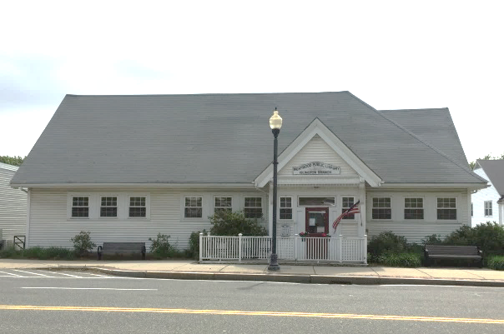
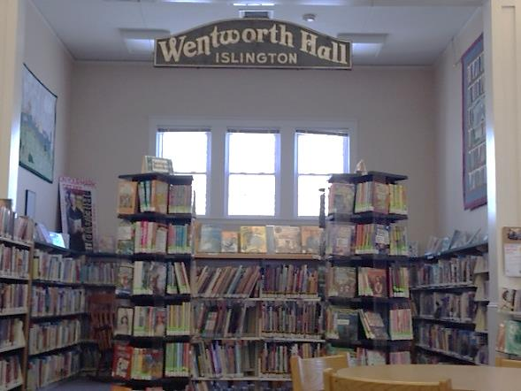

Islington Branch Library

In the past year the Islington Branch Library has been the subject of many conversations. This is a result of development that is taking place in and around Islington Center, which is the location of the Islington Branch Library. The Islington Branch Library is a vibrant and integral anchor of the Islington Center area – and the Library Trustees are committed to working with all parties to ensure that branch library services continue to be offered in Islington Center.
In the fall of 2015, the Westwood Board of Selectmen made appointments to a new committee, the Islington Center Task Force. This Task Force was appointed to study Islington Center and to encourage the appropriate redevelopment of this area. As part of this study, the Task Force was charged with exploring options for the redevelopment and/or re-use of the various town-owned parcels along Washington Street. Included as one of the town-owned parcels was Wentworth Hall – home of the Islington Branch Library.
When the town issued a Request for Proposals for the Redevelopment of Property in Islington Center (RFP); the restriction was made that proposals that called for the re-use or redevelopment of Wentworth Hall (Islington Branch Library) must include provisions for equivalent community space either within the project area or in an off-site location in a manner acceptable to the Board of Selectmen. In addition, there was a restriction on demolition specific to Wentworth Hall, specifically stating that “the building may NOT be demolished but may be relocated to an approved site and in a manner acceptable to the Board of Selectmen.”
Library Trustees made a presentation focusing on the strengths, weaknesses, challenges and opportunities facing the Branch to the Islington Center Task Force in April 2016. This presentation was intended to inform and educate the Task Force and the Westwood community at large about what the opportunities and options might be for the branch library, and to share with the community an overview of the importance of branch services and provide information about how the building and collections are presently used and what options there might be in the future. As a quick snapshot, the following items were highlighted:

- Collections / Resources / Access
  - Popular titles, Book Group selections, Speed Reads, newspapers, magazines. movies
  - Social: chat and visit, friendly staff
  - Convenient location – can walk there and/or easier pick-up & drop off
  - Easy and quick access to pick up holds (but only open 3 Days per week!)
  - Atmosphere/experience/ambiance: Quiet, less busy than the main library
  - Historical Building – lots of town history
  - Small intimate space
  - Personalized service
  - Nostalgia/continuity of their experiences growing up in Westwood
  - Convenient to public transit (bus and commuter rail)
  - Programs for adults and children
  - Wifi and printing – airline tickets, resumes, etc.
  - Public Restroom Facilities

- Patron Profile
  - “Regulars”
  - Seniors
  - Parents with young children
  - Neighborhood (convenience for pick up)
  - Transactional – quick pick-up/drop-off and quick browse/selection:
popular titles of books, audiobooks, dvds, and periodicals

Plans from developers will be reviewed over the next several months – and the impact on library branch services is certainly something that will be closely monitored by Library staff and Library Trustees.

WESTWOOD PUBLIC LIBRARY
STRATEGIC PLAN
2017-2021

SERVICE RESPONSES

SERVICE RESPONSE 1 Stimulate Curiosity and Imagination-- Reading, Viewing and Listening for Pleasure

Goal: Residents will have easy access to materials that
will enhance their leisure time and will have the help they need to make choices from among the options.

SERVICE RESPONSE 2 Lifelong Learning--Make Informed Decisions and satisfy curiosity; Express Creativity, Create and Share Content

Goal: Westwood residents will have the resources they need (including print, video, audio, or visual content in a real-world or online environment) to explore topics of personal interest. They will be encouraged to read, explore, and discover new ideas at all stages of life and continue to learn throughout their lives.

SERVICE RESPONSE 3 Create Young Readers (Birth through age 18)

Goal: Foster a culture of literacy that engages and captures the imagination of young readers (birth – age 18) and keeps them engaged with reading and literacy throughout their youth.

SERVICE RESPONSE 4 Visit a Comfortable Place

Goal: The Westwood Public Library will be the “hub” of the community. Residents of all ages will have safe and welcoming physical places to meet and interact with others or to sit quietly and read, work and study, and will have open and accessible virtual spaces that support collaboration and networking.

SERVICE RESPONSE 1: Stimulate Curiosity and Imagination-- Reading, Viewing and Listening for Pleasure

Goal: Residents will have easy access to materials that will enhance their leisure time and will have the help they need to make choices from among the options.

Objective 1: Library patrons will easily find the materials they want, either in our collection or within the network.
Action 1: The library will provide a collection of materials that is balanced between physical and electronic formats. (Print and e-books, DVDs and downloadable/streaming audio and video.)
Measure: Circulation measured and evaluated frequently to determine appropriate spending allocations are being made for the various resources and materials and to ensure that budget is adjusted to align with actual use and demand.
Measure: Weed collection areas that are crowded.
Measure: Database usage
Measure: Number of Holds requests
Measure: Digital Content Usage
Measure: Waitlist time for digital content
Measure: Weed Collections in Main Library and in Branch: Fiction/Large Print/Non-fiction/Children’s/Teens

Objective 2: Provide enhanced Readers’ Advisory Services and Programming for Patrons
Action 1: The library will maintain a knowledgeable, positive, customer service-oriented staff who can help people find and evaluate information in all formats.
Measure: Increased number of staff using current review journals to develop facility with readers’ advisory skills
Measure: Workshops and webinars attended by staff to allow them to enhance their readers’ advisory skills
Measure: Number of hours staff engaged in improving advisory skills (reading, listening and viewing options)
Measure: Number of people who report positive interactions with staff
Measure: Displays – increased number and type of smaller displays -- (for example - author of the week)
Measure: Increase merchandising of library materials
Measure: Increase staff and patron use of Readers’ Advisory websites and databases: GoodReads, Novelist, e-Sequels, etc.
Measure: Staff familiarity and use of Novelist RA for Professionals email list serve

Action 2: Increase and expand patron and staff awareness of mysteries and variety of mystery genres as part of the Readers’ Advisory initiative.
Measure: Staff will participate in Readers’ Advisory programs led by professionals (Stephanie Anderson, Leanne Ellis and Nancy Hill Malone)
Measure: Expand number and variety of mystery book displays curated by staff
Measure: Booklists – Staff Pick Mysteries
Measure: Participation by public in mystery bookgroup
Measure: Readers’ Advisory Content contributed by staff
Measure: Measure circulation statistics of mysteries to patrons
Measure: Local Mystery Author will be invited for public author talk
Measure: Attendance and participation at Mystery Author event
Action 3: Increase number and type of Book Groups supported by the Library (Pageturners, book discussions, bookshares)
Measure: Outreach to locally hosted book groups and assist with providing multiple copies of book group titles
Measure: Attendance at Library – sponsored book groups
Measure: Formation of teen and multi-generational bookgroups

Objective 3: Develop “One Book, One Town” Program to be held regularly
Action 1: The library will collaborate and partner with other local groups and town departments to develop a community-based committee for a One-Book, One-Town programming initiative.
Measure: Identify and invite author for book talk and book signing
Measure: Coordinate acquisition of sufficient number of books via interlibrary loan or library/individual purchase in order to allow patrons sufficient time to read book prior to event – also make available title in multiple formats (audio, downloadable, etc)
Measure: Schedule activities and events
Measure: Marketing and publicity of event to the community
Measure: Develop programming collaborative efforts with local groups, for example Fox Hill Village, COA, local book groups, Rotary, etc.
Measure: Library Director to reach out to local groups – Rotary, COA, Bridges by Epoch, etc. to promote library identity and programming.
Measure: Identify options for engaging residents and businesses at University Station
Measure: Identify additional sponsorship opportunities for programming support
Measure: Identify title and reading initiative for younger readers to coordinate with selected adult title
Measure: Social Media Impact (#tweets, likes on Facebook, etc.)

Objective 4: Increase circulation of materials of all types. Make efforts to increase circulation of books, while also expanding knowledge, understanding and availability of new media (streaming, downloadable)
Action 1: Provide additional copies of relevant and high demand titles through purchase of additional copies (increase availability and access to high demand and popular materials)
Measure: Patron awareness of popular book titles (webpage links, flyers, etc.)
Measure: Circulation Statistics
Measure: Technology assistance workshop participation by patrons to assist with access to digital content
Measure: Circulation statistics for speed views, speed reads, and high demand titles

Action 2: Research purchase of Rokus for public circulation
Measure: Explore costs and benefits
Measure: Develop usage information for patron’s ease of use and access
Measure: Devise circulation procedures
Measure: Evaluate

Action 3: Increase patron usage of digital content (Overdrive/Hoopla)
Measure: Increased publicity and focus on digital content
Measure: Create E-Content program to introduce patrons to digital content and devices
Measure: Usage statistics
Measure: Funding Level
Measure: Holds Management/Wait time
Measure: Collection Size and formats (ebook/audiobook/video/music/etc.
Objective 5: Create Additional Publicity – including outreach and regular publishing of a Library Newsletter (electronic /online)
Action 1: Publish a regular online newsletter to be distributed electronically informing patrons of new materials, upcoming events and programs using Booksite Connect
Measure: Number of email addresses on distribution list
Measure: Newsletter content created
Measure: Marketing and publicity and p/r to inform patrons of availability and link with town public relations opportunities (town newsletter, opt-in options for town website links)
Measure: Increase involvement of Trustees as ambassadors for Library (Coffee with Trustees and Friends as a regular program)
Measure: Increase outreach provided by Library Director
Measure: Number of issues produced by library staff
Measure: Patron feedback and comments

SERVICE RESPONSE 2: Lifelong Learning--Make Informed Decisions and satisfy curiosity; Express Creativity, Create and Share Content

Goal: Westwood residents will have the resources they need (including print, video, audio, or visual content in a real-world or online environment) to explore topics of personal interest. They will be encouraged to read, explore, and discover new ideas at all stages of life and continue to learn throughout their lives.

Objective 1: Residents will see the library as a place to go for help creating original work.
Action 1: The library will create a makerspace environment to encourage creation of diverse types of content.
Measure: Makerspace created.
Measure: Makerspace promoted in the community.
Measure: Number of community members using the space.
Measure: Number of volunteers offering classes.
Measure: Number of paid presenters offering classes.
Measure: Number of hours makerspace is available to the public.
Measure: Number of items purchased for the library collection to support makerspace offerings.
Measure: Number of people who attend classes or one-on-one sessions.
Measure: Number of people who use makerspace equipment or technology to create content.
Measure: Number of people who create and share content with others in the community.

Action 2: The library will offer hands-on workshops in a variety of media (electronic and non-electronic) for residents of all ages.
Measure: Number of programs offered.
Measure: Number of people participating.
Measure: Number of art shows/gallery openings.
Measure: Number of non-traditional programs offered (ex: theater, art, book publishing, etc)
Measure: Number of items purchased for library collection to support program offerings.
Measure: Updated and refreshed technology available for use by patrons

Action 3: The library will seek partnerships and donations to ensure the sustainability of the makerspace.
Measure: Number of partnerships sought and created/sustained.
Measure: Number of items donated.
Measure: Increased visibility and outreach by Friends of the Library, Trustees and Library Director

Objective 2: Library will take appropriate steps to ensure that materials of local interest are preserved for future generations
Action 1: Identify materials in library or other collections (town department/local organizations) as candidates for digitization.
Measure: Number and types of items and materials to be digitized
Measure: Use of digitized materials
Measure: Costs involved

Objective 3: The library will provide an array of services and offerings to people of all ages, from babies through senior citizens.
Action 1: Staff will partner with other local organizations to co-sponsor lectures or demonstrations on topics of interest to a wide variety of age groups.
Measure: Number of potential partner organizations identified
Measure: Number of partnerships created/sustained.
Measure: Community input sought for new programs or initiatives
Measure: Number of collaborative programs held.
Measure: Number of people attending programs.
Measure: Number and types of donations

Action 2: Library staff will reach out to groups of residents who are underserved by the library to help them become library users.
Measure: Number of residents participating in Doorstep Delivery Program for homebound residents
Measure: Number of new services or programs for younger seniors approaching retirement who are still actively working.
Measure: New ways to engage twenty- and thirty-somethings sought
Measure: Number of library cards issues to seniors or patrons in other specific age groups

Action 3: Library Staff will enhance collections, services and programming for teens and ‘tweens at the Westwood Public Library
Measure: Number of new services for teens and ‘tweens.
Measure: Participation in teen programs.
Measure: Ensure that every teacher and school administrator is aware of the library’s ability to provide students with homework assistance, access to technology and diverse collections
Measure: Develop resources that support school curriculums through collaborative relationships with educators.

Action 4: Continue to expand collaborative efforts and activities between the Westwood Public Library and the Westwood Public Schools, including possibility of providing additional online reference resources to support school curriculum.
Measure: Number of collaborative projects.
Measure: Variety of grades participating.
Measure: Number of students participating.
Measure: Evaluate cost of additional online resources (JStor?)

Objective 4: Provide entrepreneurial/arts programming in order to provide greater support for local businesses, artists and authors.
Action 1: Identify programming opportunities to showcase interests, talents and skills of local residents
Measure: Establish “How To” Festival / Showcase
Measure: Number of presenters
Measure: Number of attendees
Measure: Community Interest in event

Action 2: Establish an annual meeting (program) featuring local Westwood authors
Measure: Create list of local authors and artists
Measure: Number of events held.
Measure: Number of people attending events.
Measure: Number of items purchased for the collection to support events.

Action 3: Develop intergenerational programming that inspires people to share stories across ages and cultures.
Measure: Develop intergenerational programming that inspires people to share stories across ages and culture
Measure: Explore participation in Seekers & Sages Program (in collaboration with High School?)
Measure: Expand collaborative programming with Westwood COA, Bridges by Epoch, Foxhill Village, etc.

Action 4: Explore opportunities for collaborative or networking events and initiatives to support entrepreneurs, local business people or arts groups
By 2020, 1 in 6 people will be an entrepreneur. That is why co-authors Ja-Nae Duane and Steve Fisher of the bestselling book, The Startup Equation, A Visual Guidebook to Building Your Startup are on a mission to help 1 million entrepreneurs.
Measure: Explore establishment of collaborative networking events, for example Krosslink Group
Measure: Number of Events
Measure: Number of participants
Measure: Increased collaboration and liaison with local groups such as Chamber of Commerce, Small Business Enterprises, etc.

SERVICE RESPONSE 3: Create Young Readers (Birth through age 18)
Goal: Foster a culture of literacy that engages and captures the imagination of young readers and keeps them engaged with reading and literacy throughout their youth.
Objective 1: The Library will increase number and variety of materials that reflect the ethnicities and languages represented by the residents of Westwood.
Action 1: Measure the demand for materials in foreign languages
Measure: Develop and expand collection development for purchase of materials in foreign languages
Measure: Purchase materials in variety of formats; including audio, video, e-content
Measure: Explore development of multi-lingual storytimes
Measure: Investigate need for ESL resources

Objective 2: Expand children’s and youth programming to attract wider audience.
Action 1: Establish more formalized liaisons with Middle School and High School teachers and librarians.
Measure: Library staff will meet with curriculum coordinators and librarians at Middle/High School.
Measures: Summer Reading Program – increase coordination with Middle and High School teachers.

Action 2: Explore opportunities for focused programming specific to Middle and High School Students (for example Reading Incentive Programs, Special Interest Clubs and Youth/Teen Book Clubs)
Measure: Survey teens to determine wants and needs on an annual basis (survey sixth graders during 6th grade visit)
Measure: Revitalize TAB Group
Measure: Continue “Fun Teen Book Group” for Teens and ‘Tweens.
Measure: Teen programs held at least 5 times per month, including evening or weekend programs.
Measure: Explore opportunities for establishing identified teen and “tween collections and programs in both children’s and young adult areas
Measure: Continue with Teen Study Nights and capture statistics on use of library for these events
Measure: Explore option for outreach for Middle School -- sixth grade lunch book group at the school.
Action 3: Request additional staffing for dedicated Young Adult Librarian
Measure: Secure funding for additional position
Measure: Recruitment and hiring of Young Adult Librarian (20 – 35 hours)

SERVICE RESPONSE 4: Visit a Comfortable Place

Goal: The Westwood Public Library will be the “hub” of the community. Residents of all ages will have safe and welcoming physical places to meet and interact with others or to sit quietly and read, work and study, and will have open and accessible virtual spaces that support collaboration and networking.

Objective 1: Make library resources more accessible to all community members
Action 1: Bring library resources to where people are
Measure: Establish “doorstep delivery” to transport library materials to homebound residents.
Measure: Investigate extended loan periods for homebound residents

Action 2: Establish the Westwood Public Library as a civic focal point and resource
Measure: Notary Public Services to be available at Main Library and Islington Branch
Measure: Investigate possibility of providing passport services at the Library

Action 3: Explore options for increased access to assistive technologies for our patrons
Measure: Explore some or all of the following—and other technologies as they become available:
Screen Magnification Software
Adaptive Keyboards
Low Vision Assistive Technologies
Braille Translation Software
Braille Embosser
Refreshable Braille Display
Scanning Systems and Software
Electronic Notetakers
Adaptive Mouse or Joystick
Portable Magnifier
Learning Disability Software
Speech Recognition Software
Audio Recognition Software
Headphones

Action 4: Explore possibility of creating circulating Ipads preloaded with apps to assist people with autism or learning difficulties, and to promote general literacy (similar to program initiated by Putterham Branch in Brookline).
Measure: Ipads and Apps purchased and made available
Measure: Usage statistics
Measure: Patron feedback and comments
Measure: Programming options for children on the spectrum
Measure: Family programs and activities which also link to library’s resources
Measure: Collaborative efforts with SEPAC and schools and local preschools

Objective 2: Library Trustees and staff will work with town officials to determine best options to make the Islington Branch a 21st century library that will meet residents’ needs for years to come.
Activity: Review layout and program space needs for Islington Branch Library
Measure: Explore options to improve patron experience with improved space utilization
Measure: Explore opportunities to increase usable public space.
Measure: Self-checkout implemented
Measure: Signage and wayfinding improved
Measure: Explore options to improve energy efficiency and ambiance (i.e. lighting, HVAC, wireless connectivity, etc..)
Measure: Explore optimal hours of service for branch location
Measure: Analyze hours branch is open

Objective 3: The library will provide meeting space for groups to gather for club meetings, discussions, lectures, and other nonprofit activities.
Action 1: The library will improve its meeting spaces to meet the needs of local groups.
Measure: Look into possibilities for purchase of more flexible, multi-use furnishings; including adjustable height task chairs for public computer stations.
Measure: Number of requests received from patrons for additional meeting spaces
Measure: Number of comments received about the space.
Measure: Explore potential for online booking of community room and conference room spaces
Measure: Look into options for promoting availability of community space
Measure: Explore options for increased visibility and use of gallery space (network events, increased promotion of available exhibit spaces).

Action 2: Lighting, shelving and seating will be evaluated, potentially to carve out smaller “living room” spaces within the Main Library
Measure: Explore rearrangement of shelving and seating
Measure: Explore options for improved lighting to make the space brighter—particularly in large print area and along 2nd floor perimeter.
Measure: Explore purchase and installation of more multi-purpose furnishings
Measure: Provision of noise-cancelling headphones to for public use

Action 3: Explore noise mitigation for gallery area and second floor of main library
Measure: Investigate options available to reduce noise in these public spaces

Objective 4: Explore options for improved communication (internal and external) for library events and programs
Action 1: Enhance library’s social media presence and interaction with community
Measure: Expand library social medial content
Measure: Patrons who interact with library’s social media outlets (Twitter, Facebook, Blog Posts, Newsletter, etc..).

Action 2: Explore information screens/monitors to display current events and programs happening at the library
Measure: Selection of equipment (electronic display) for lobby area
Measure: Installation
Measure: Comments received from patrons
Measure: Continue to expand and update library blog posts

Action 3: Publish a regular online newsletter to be distributed electronically informing patrons of new materials, upcoming events and programs using Booksite Connect
Measure: Number of email addresses on distribution list
Measure: Newsletter content created
Measure: Marketing and publicity and p/r to inform patrons of availability and link with town public relations opportunities (town newsletter, opt-in options for town website links)
Measure: Number of issues produced by library staff
Measure: Patron feedback and comments

Objective 5: Address the role of the public library in responding to public safety and security concerns
Action 1: In conjunction with public safety officials of the town, Develop plans for scenarios that would involve public safety concerns relative to the staff and patrons in the library: for example, what to do if “shelter in place” is issued; active shooter, etc…
Measure: Establish emergency procedures to provide instructions to staff/patrons in cases of:
fire/smoke, flooding, injury/illness, burglary/theft, power failure/elevator malfunction,
gas leak/hazardous material spill, bomb threat, active shooter, climatic emergencies, disruptive
behaviour, crime with violence; missing child.
Measure: Establish procedures to facilitate communication and coordination – emergency contact information and notification procedures
Measure: Work with public safety to establish emergency “lock down” procedures.
Measure: Distribute procedures to staff, other town agencies (fire, police, etc).
Measure: Maintain procedures manual – printed and bound in highly visible binder easily accessible in multiple staff areas at the Main Library and at the Islington Branch.
Measure: Practice knowledge of the fire alarm system and procedure to follow in the event of a fire alarm, including public exit and re-entry into building.
Measure: Fire Department will conduct annual “fire drill”

APPENDIX A: Invitation to Join Community Focus Group for Westwood Public Library Strategic Planning--February 2016
Every five years, public libraries in Massachusetts are required to submit long range plans to the Massachusetts Board of Library Commissioners. Beginning in February 2016, the Westwood Public Library Trustees and staff will begin working on the development of a new strategic (long-range) plan for the Library.
There will be several facets to the strategic planning process, including the development of a community survey and the formation of a Community Focus Group. The goal is to engage in a public discussion relating to the future and values of the Westwood Public Library—including the components of the library’s mission such as literacy, innovation and community engagement. Participants will explore the role and value of the Westwood Public Library and provide feedback and information that will guide the formulation of the library’s strategic plan. The Focus Group will assist the Trustees and staff on the development of assessment tools for the Strategic Plan – including analysis of the social, economic and demographic characteristics of our community and a SOAR assessment of the library:

- STRENGTHS WHAT WE’RE DOING WELL
- OPPORTUNITIES WHAT CAN WE IMPROVE
- ASPIRATIONS WHAT WE’D LIKE TO BECOME
- RESULTS WHAT SUCCESS LOOKS LIKE FOR US

The final product will be a five-year long range plan that will identify the mission and vision of the Westwood Public Library.

You are receiving this letter because we would like to invite you to be a member of this Community Focus Group. This is a working group of approximately 20 individuals who represent a variety of interests, skills and expertise. The time commitment for participation in the Community Focus Group will include reading materials provided prior to the session and attendance at one three hour meeting on Tuesday, April 26th from 7 pm to 10 pm. This meeting will be held in the Community Room at the Main Library, with light refreshments (sandwiches, coffee, juice) provided.
We do hope that you will be able to join us for what will be an informative and lively discussion. Please RSVP by March 10th by contacting Tricia Perry, Library Director at 781-320-1041 or via email at tperry@townhall.westwood.ma.us.
Yours sincerely,
Trustees of the Westwood Public Library

Mary Masi-Phelps, Chair
Karen Coffey
Mary Beth Persons

Amy Rands
Wendy Thornton
Rich Wade

APPENDIX B: List of Community Focus Group Participants

John Antonucci
Lina Arena DeRosa
Eric Arnold
Dave Atkins
Nicole Banks
Sarah Baroud
Jackie Bassett
Sean Bevan
Tina Bronkhorst
John Cummings
Barb Delisle
Nancy Donahue
Margery Eramo
Don Friedl
Mary Gorman
Barbara Hayes
Maryellen Larose
Mary Layden
Nora Loughnane
Janet Lucey
Karen Manor
Joan Manchester
Diana Martucci
Steve Ouellette
Peter Paravalos
Jennifer Power
Deputy Michael Reardon
Erin Sibley
Barbara Silverstein
Ann Thomas
Jessie Turbayne
Lisa Walker
Leslie Warner Maloney
Mary Masi-Phelps, Trustee
Amy Rands, Trustee
Mary Beth Persons, Trustee
Wendy Thornton, Trustee
Tricia Perry, Library Director

APPENDIX C: Annotated Survey Results (Compiled by Tina Bronkhorst)
Powerpoint File- full print view attached as well
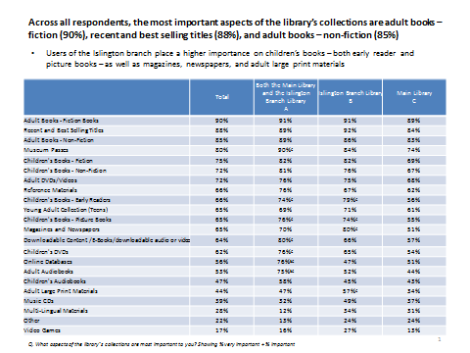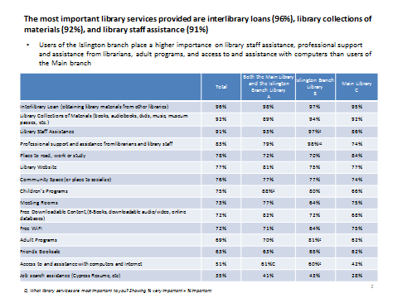
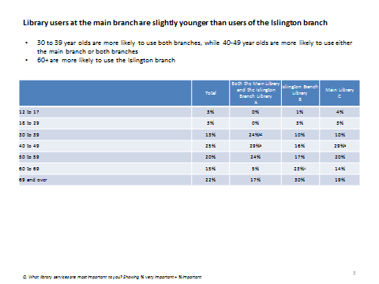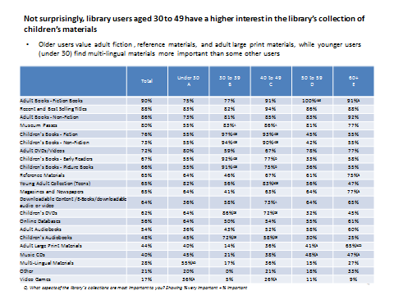

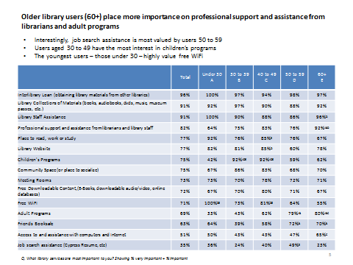

APPENDIX D: Survey Results (Google Docs) – File attached as well as printout of results

